

STUDENT NAME: CAROLINE MATHEMBO MUSYOKA
ADM NUMBER : BSCCS/2024/74753
COURSE : COMPUTER SCIENCE
UNIT CODE : BIT 3208
UNIT NAME : ADVANCED WEB DESIGN AND DEVELOPMENT
LECTURER NAME : NYORO MICHAEL
SEMESTER : MAY/AUGUST 2026
PROJECT TITLE : E-COMMERCE
SELECTED TECHNOLOGIES : PHP+MYSQL
GITHUB LINK: https://github.com/mathembocarol6-jpg/BIT3208.git

Contents
WEEK 1: LOCALHOST TESTING AND DATABASE CONNECTIVITY TESTING 4
1. INSTALLED LOCALHOST 4
Figure 1.0: XAMPP control panel 4
2. LOCALHOST TESTED SUCCESSFULLY 4
Figure 1.1: http://localhost/phpmyadmin/ 4
3. HELLO WORLD PAGE 5
Figure 1.2: HELLO WORLD Test page 5
4. BASIC DATABASE CONNECTIVITY 5
Figure 1.3.0: sample database 5
Figure 1.3.1: database connection string 5
Figure 1.3.2: successful database connection 6
WEEK 2: UI/UX AND DESIGN FOUNDATIONS 6
1. DESIGNED WIREFRAMES 6
Figure 2.0: canva design of the login page 6
2. DESIGNED GUI CONCEPTS 7
Figure 2.1: GUI design 7
3. SELECTED PROJECT THEME 7
4. CHOSEN TECHNOLOGY 7
WEEK 3: FRONTEND AND BACKEND PROGRAMMING FOUNDATION 8
1. JavaScript Basics 8
a) implemented JavaScript Basics 8
Figure 3.2: Created Form Validation 11
2. DOM Manipulation 12
Figure 3.3: successful DOM Manipulation 12
3. Introduction to PHP 13
Figure 3.4: Tested PHP Syntax 13
4. Database Connection 13
Figure 3.5: Successful Database Connection 13
WEEK 4: DYNAMIC BACKEND PROCESSING AND REAL USER INTERACTION SYSTEMS 14
1. Login form 14
Figure 4.0: login form 14
2. Form validation 15
Figure 4.1: form validator 15
3. PHP processing 16
Figure 4.2: user authentication processing 16
4. Folder structure 16
Figure 4.3: folder 16
WEEK 5: BUILDING DATA-DRIVEN SYSTEMS USING DATABASES 17
1. DATABASE CREATION 17
Figure 5.0: creating customer database 17
2. TABLE CREATION THROUGH SQL QUERIES 17
Figure 5.1: creating customer table 17
3. CRUD OPERATIONS 18
Figure 5.2.0: Create 18
Figure 5.2.1: Read 18
Figure 5.2.2: Update 18
Figure 5.2.3: Delete 18
4. REPOSITORY UPDATE 19
Figure 5.3: GITHUB Updates page 19

WEEK 1: LOCALHOST TESTING AND DATABASE CONNECTIVITY TESTING

INSTALLED LOCALHOST

Figure 1.0: XAMPP control panel
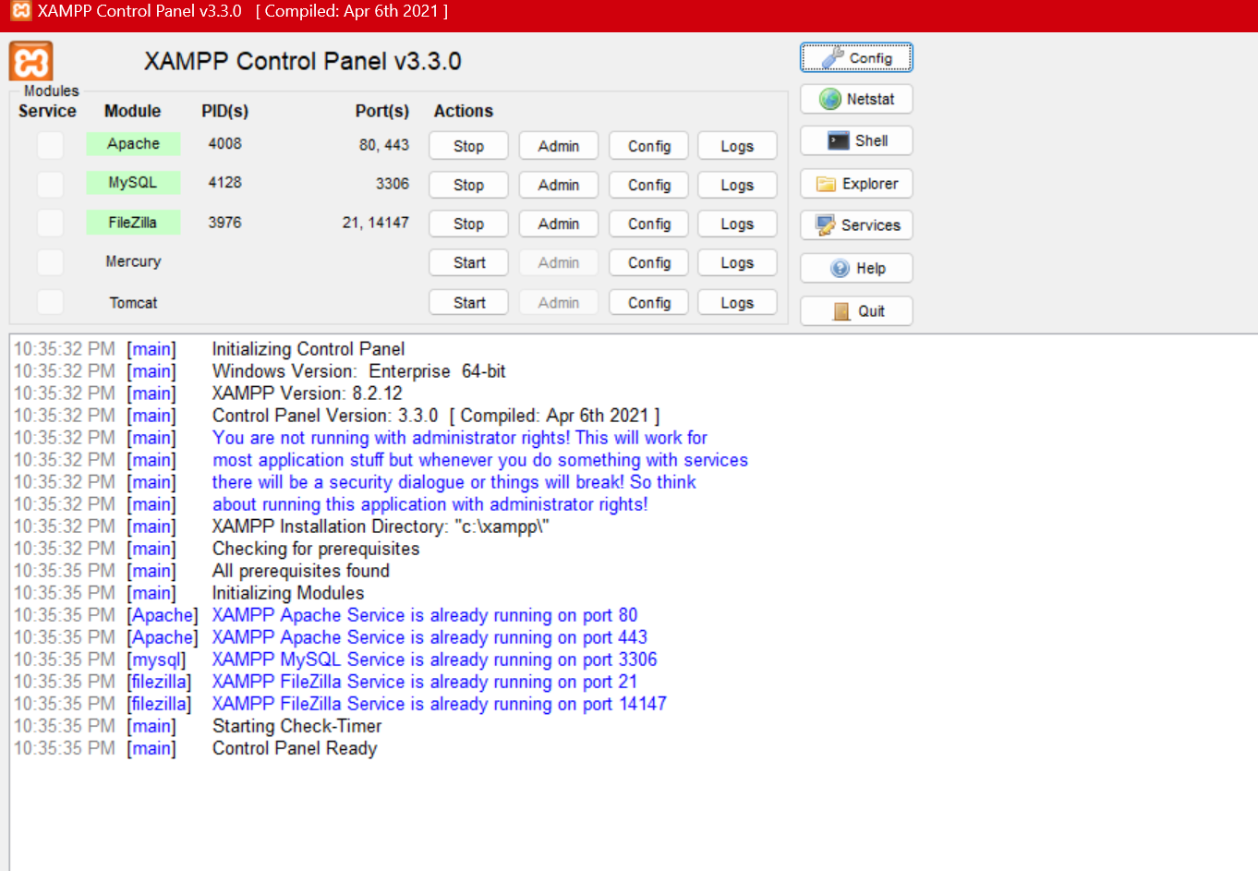

LOCALHOST TESTED SUCCESSFULLY

Figure 1.1: http://localhost/phpmyadmin/
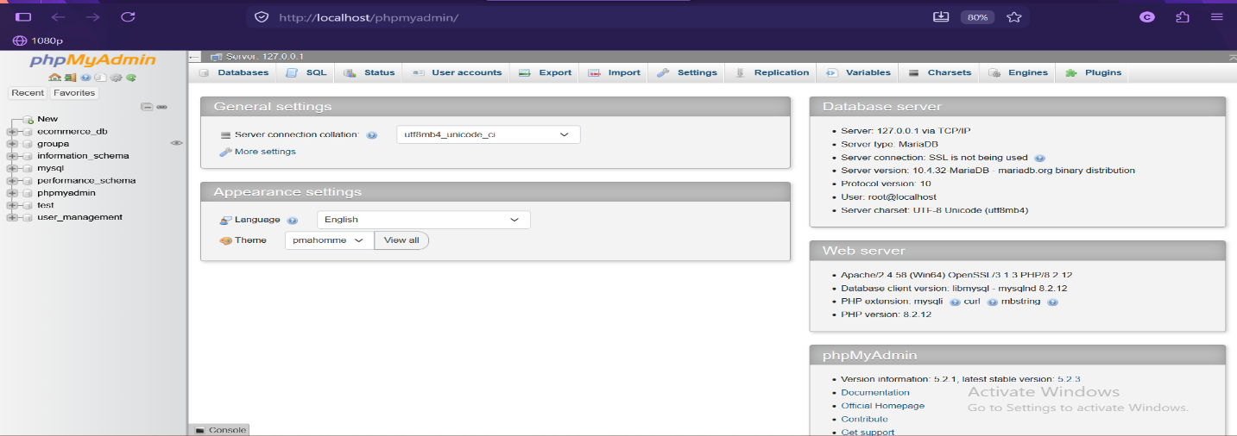

HELLO WORLD PAGE

Figure 1.2: HELLO WORLD Test page
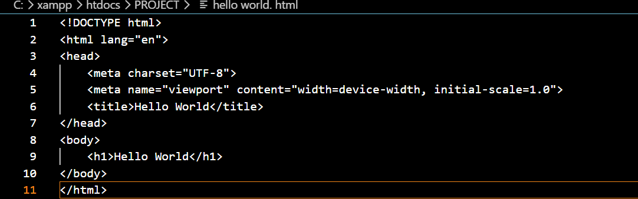


BASIC DATABASE CONNECTIVITY

Figure 1.3.0: sample database
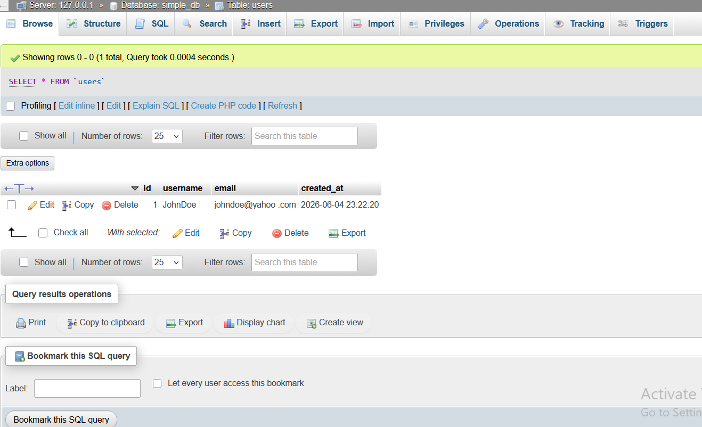

Figure 1.3.1: database connection string
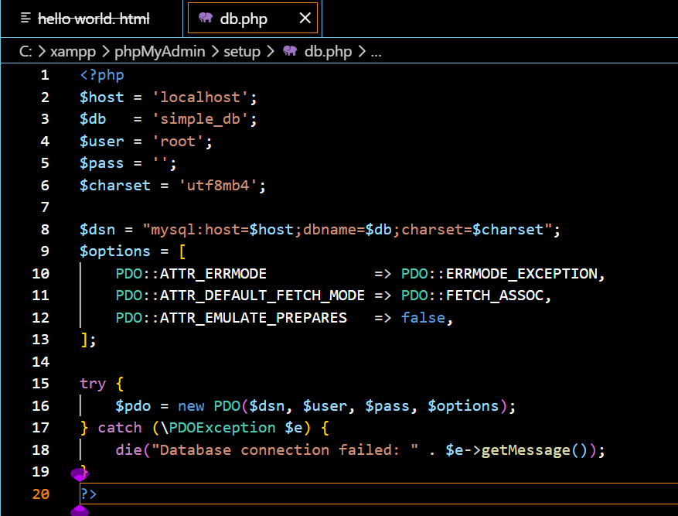

Figure 1.3.2: successful database connection
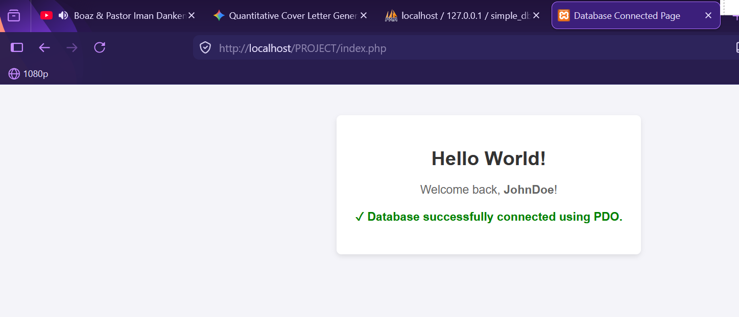

WEEK 2: UI/UX AND DESIGN FOUNDATIONS

DESIGNED WIREFRAMES

Figure 2.0: canva design of the login page
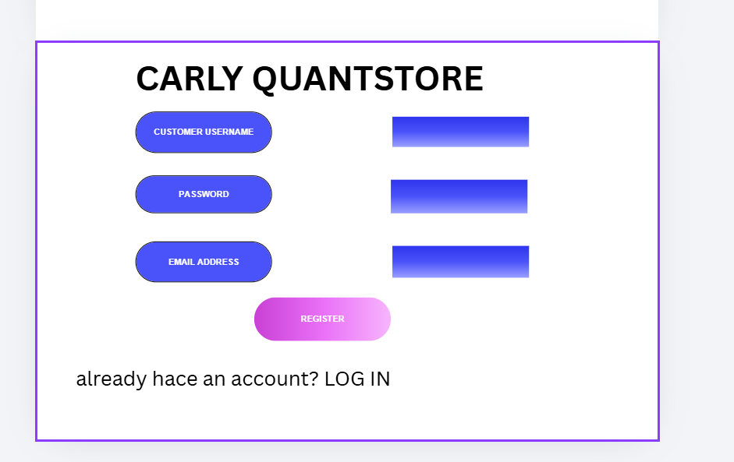

DESIGNED GUI CONCEPTS

Figure 2.1: GUI design
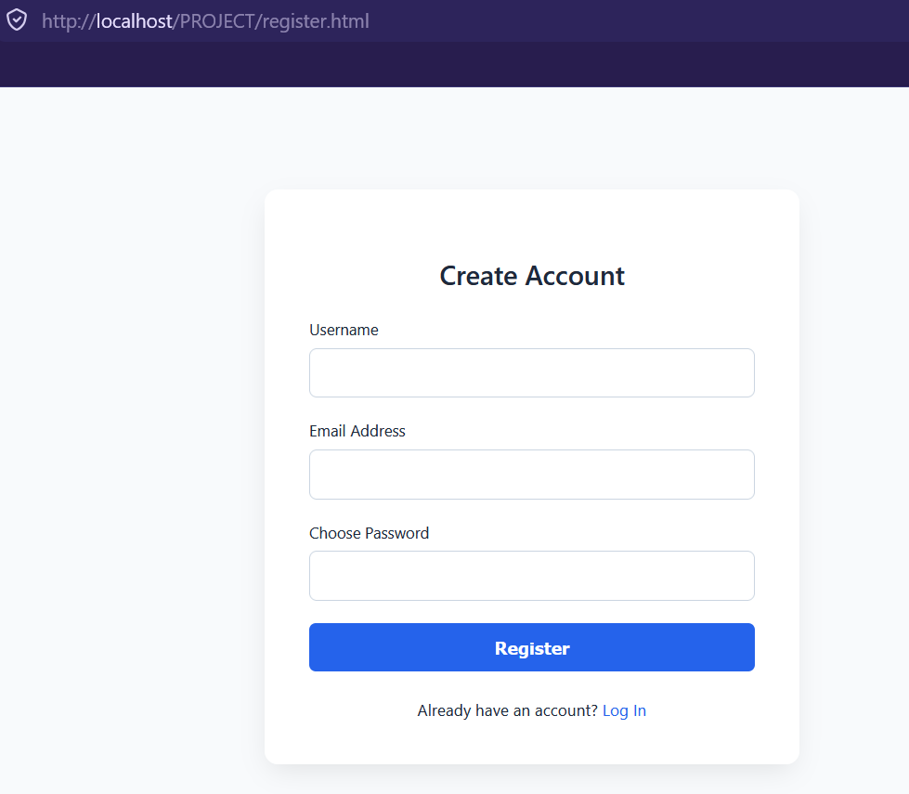

SELECTED PROJECT THEME
I have selected Digital Tech and Gadget Marketplace because tech platforms rely heavily on clean categorization and specification filtering. My MySQL can utilize a structured relational layout to handle precise product attributes. A dynamic product filtering matrix where JavaScript handles search and category filters on the client side by querying your PHP REST API asynchronously.

CHOSEN TECHNOLOGY
For my project I have used PHP, MySQL and Native JavaScript

WEEK 3: FRONTEND AND BACKEND PROGRAMMING FOUNDATION

JavaScript Basics

implemented JavaScript Basics

figure 3.1.0: user implementation
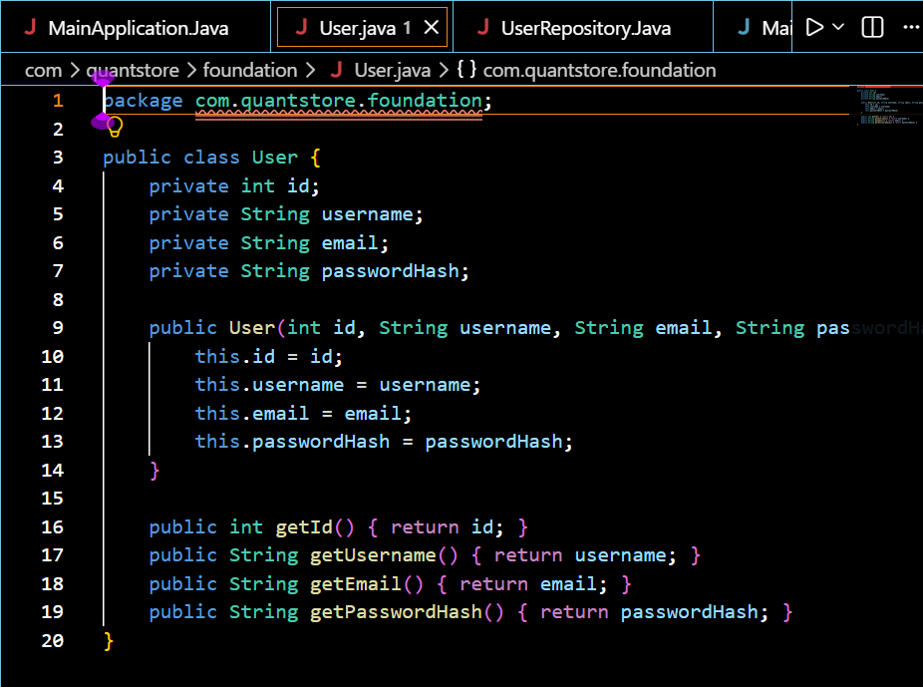

Figure 3.1.1: user repository implementation
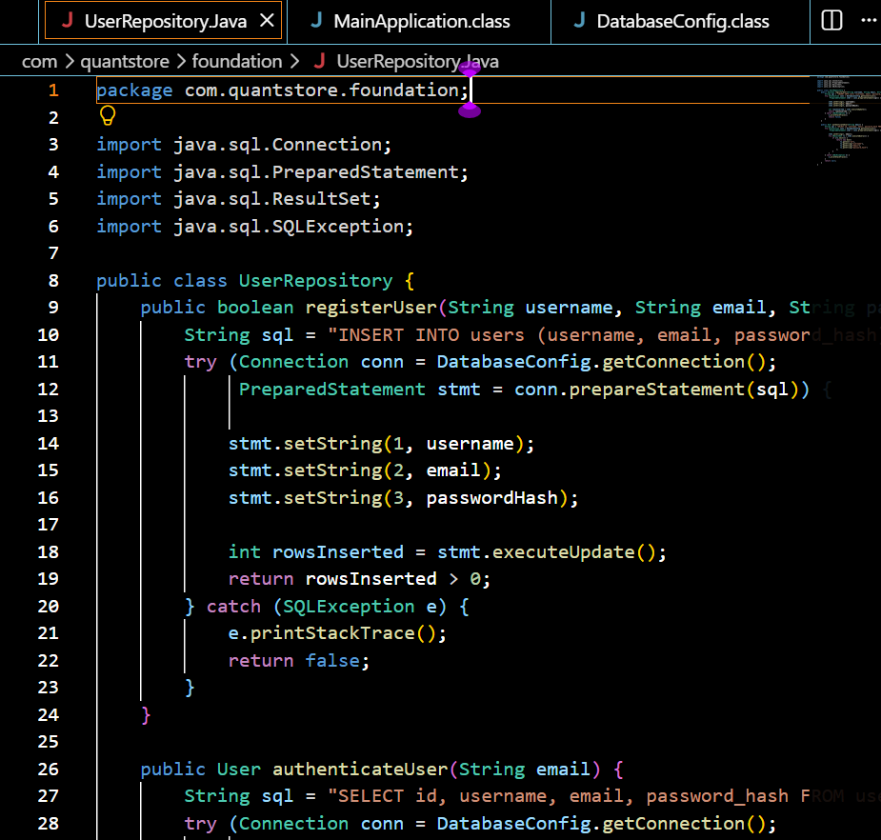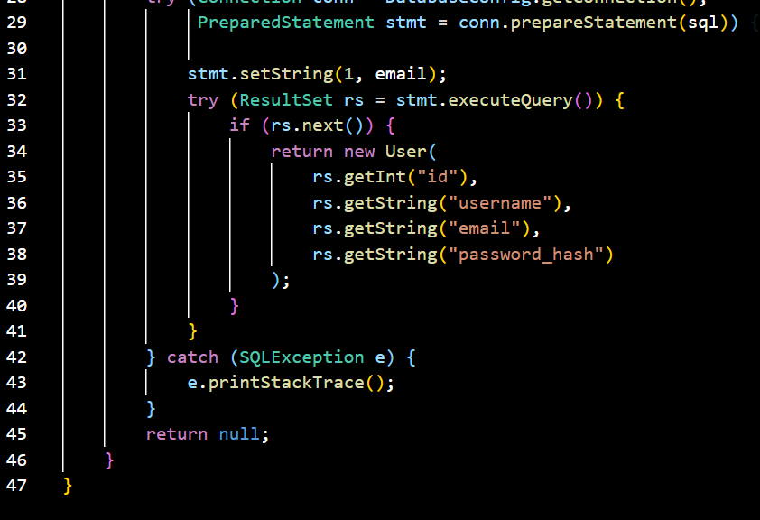

Figure 3.1.2: database configuration implementation
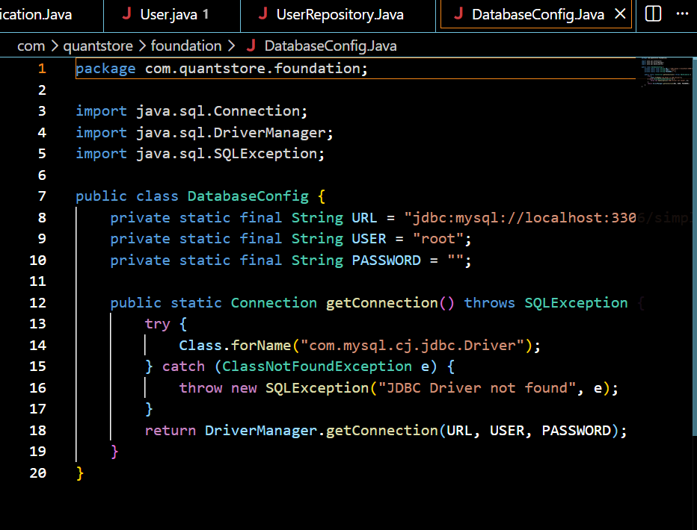

Figure3.1.3: main application java implementation
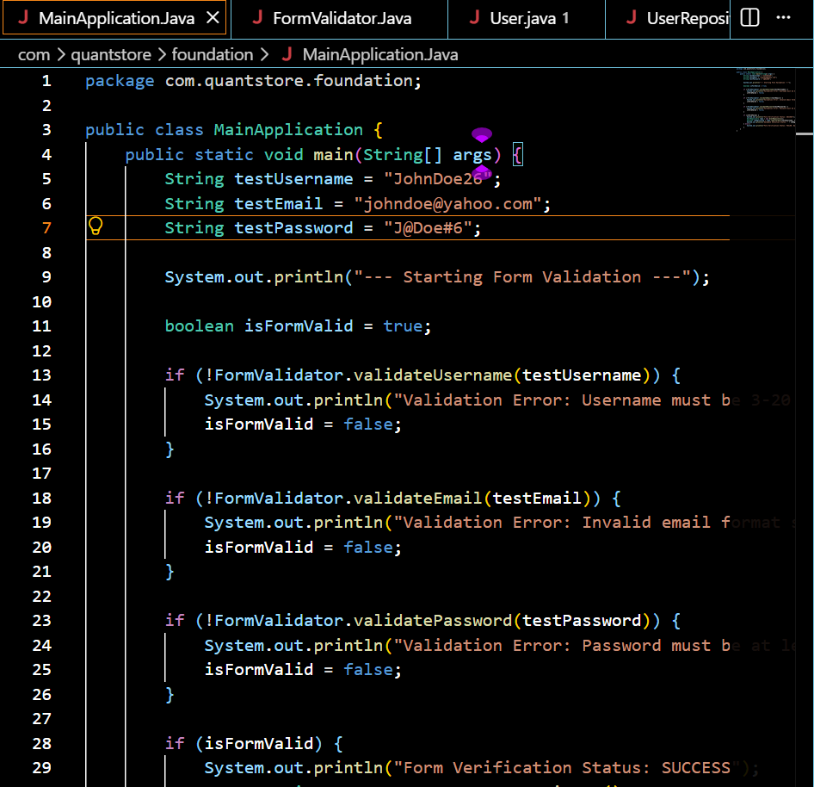
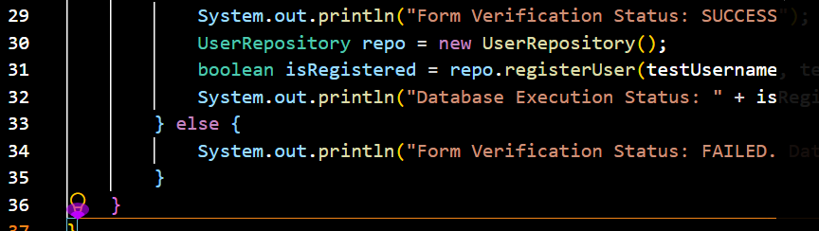

Figure 3.2: Created Form Validation
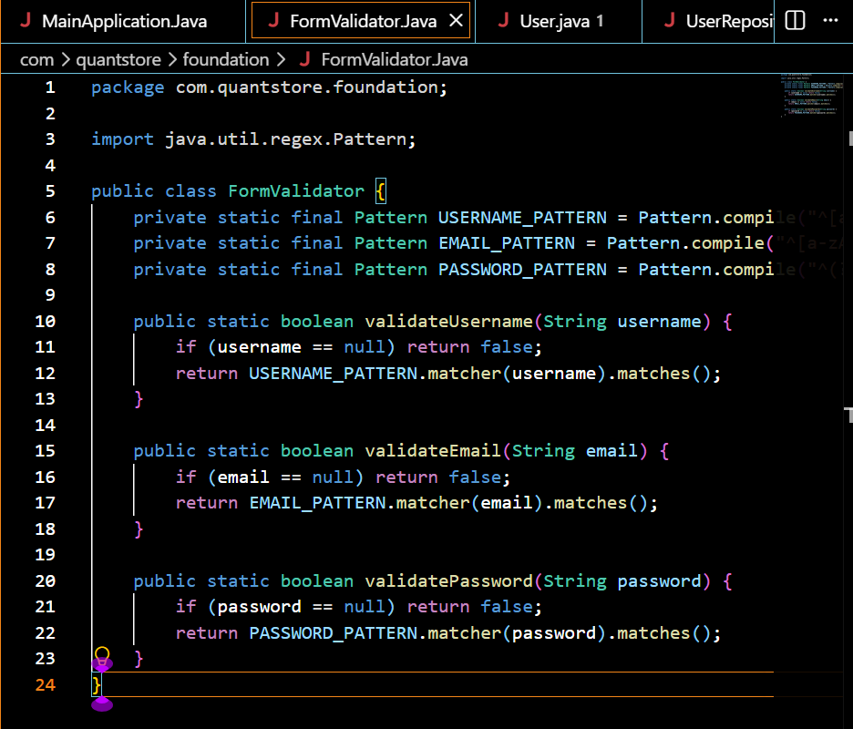

DOM Manipulation

Figure 3.3: successful DOM Manipulation
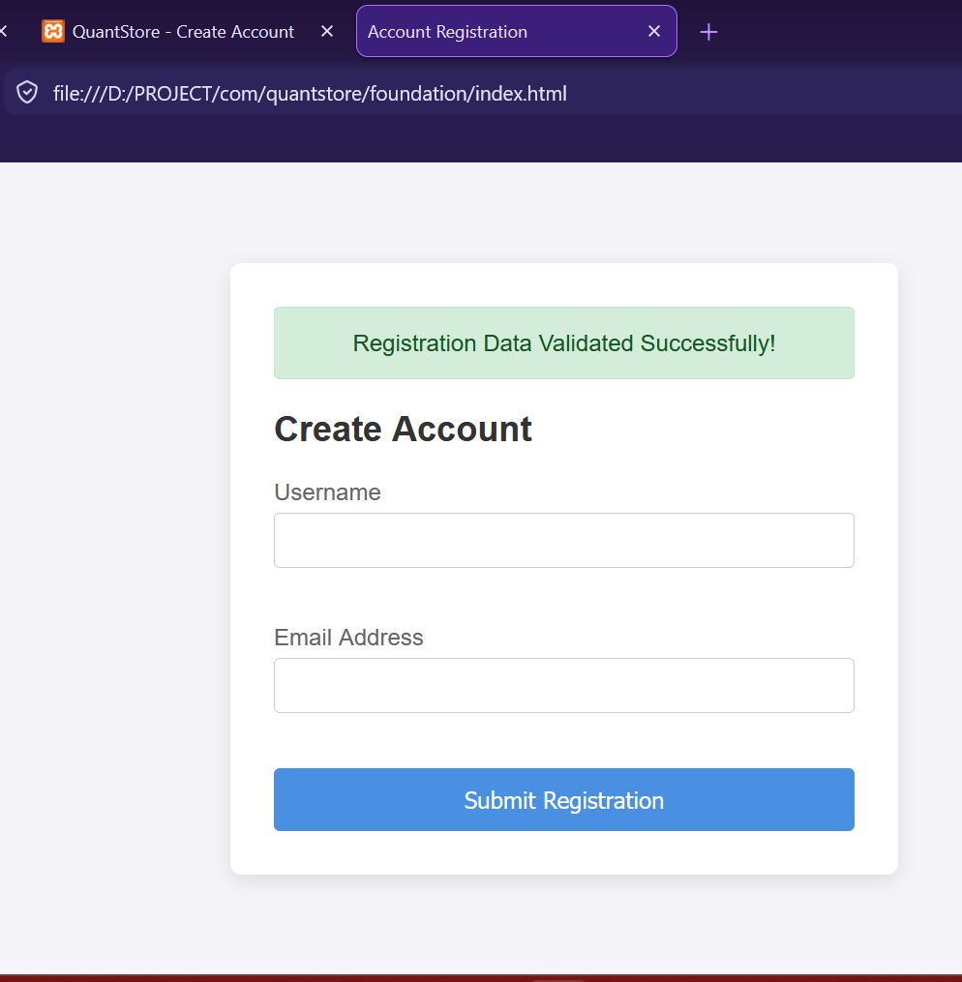

Introduction to PHP

Figure 3.4: Tested PHP Syntax
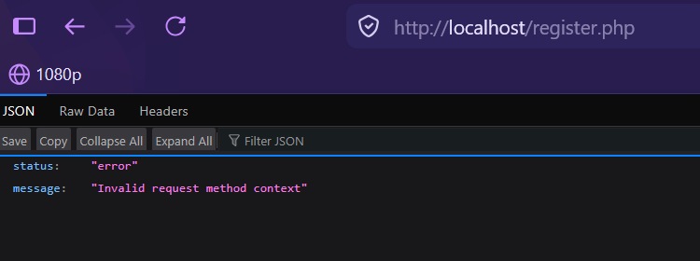

Database Connection

Figure 3.5: Successful Database Connection
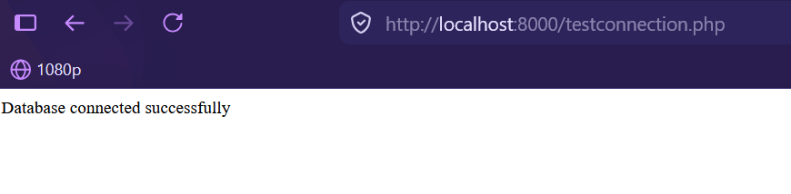

WEEK 4: DYNAMIC BACKEND PROCESSING AND REAL USER INTERACTION SYSTEMS

Login form

Figure 4.0: login form
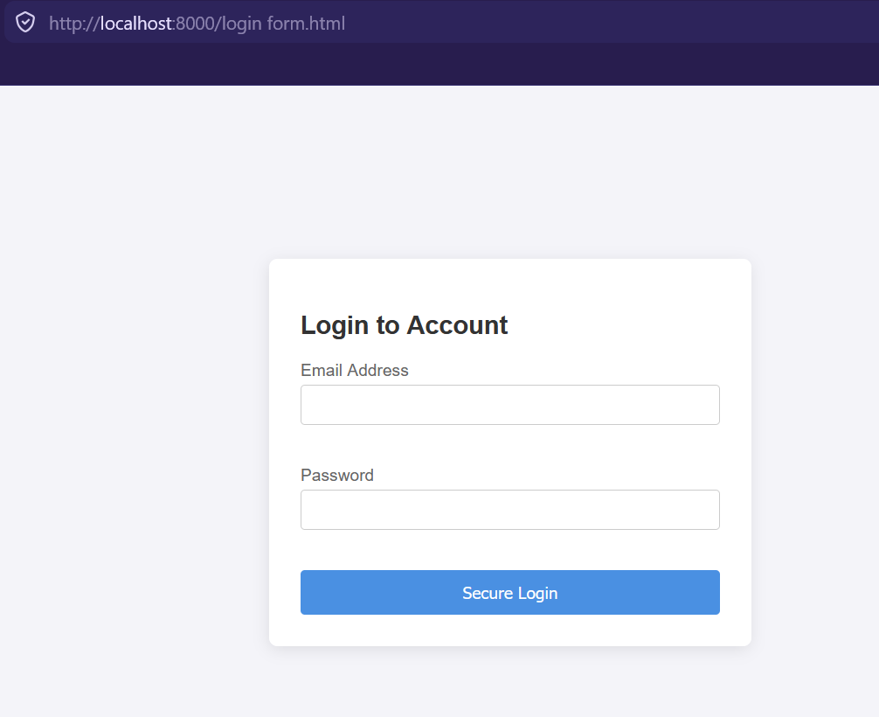

Form validation

Figure 4.1: form validator


PHP processing

Figure 4.2: user authentication processing
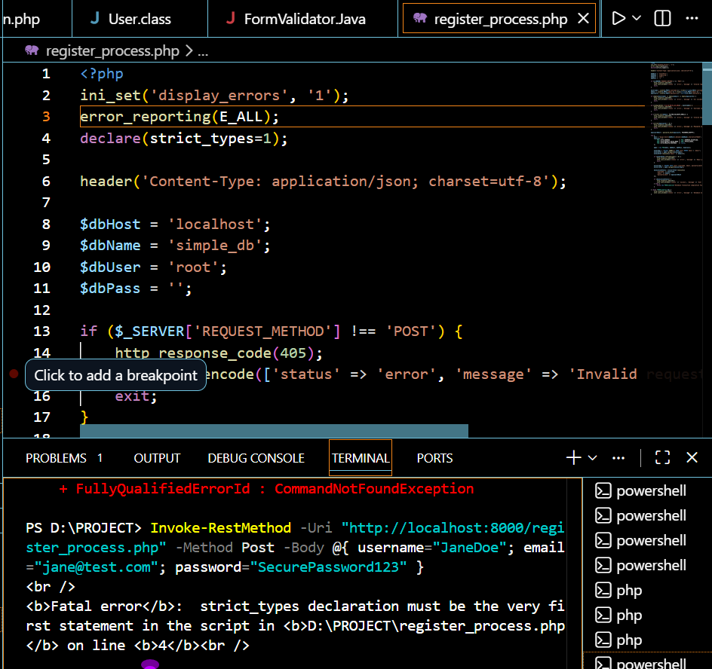

Folder structure

Figure 4.3: folder
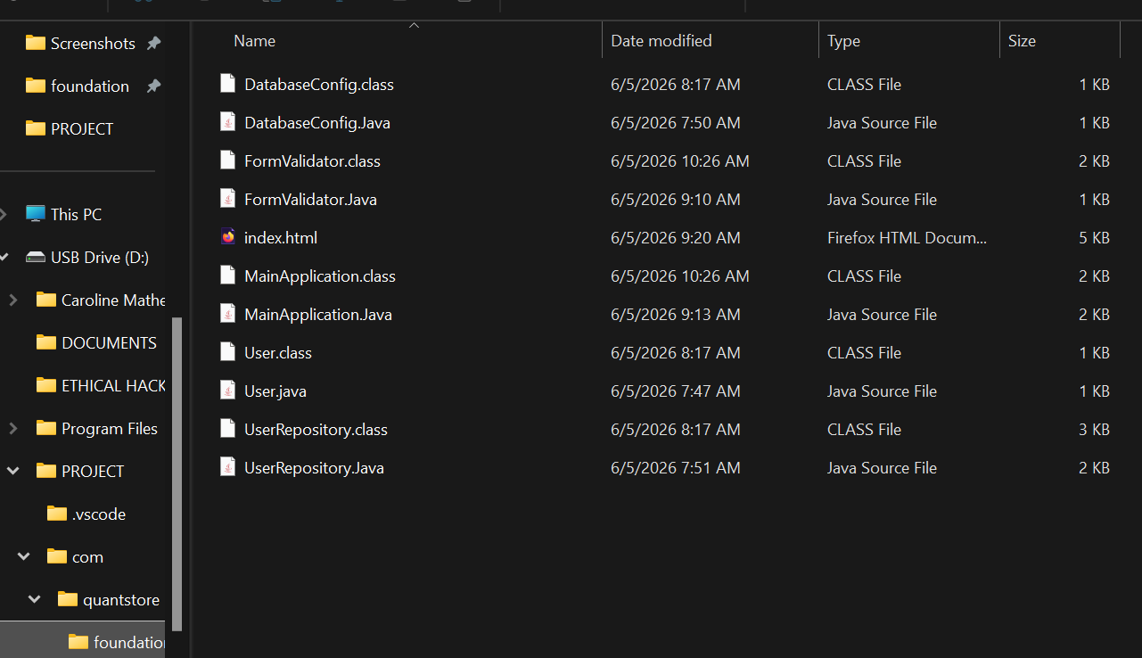

Database connection

Figure 4.4: successful database connection



WEEK 5: BUILDING DATA-DRIVEN SYSTEMS USING DATABASES

DATABASE CREATION

Figure 5.0: creating customer database
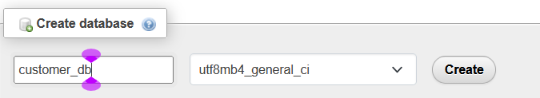

TABLE CREATION THROUGH SQL QUERIES

Figure 5.1: creating customer table
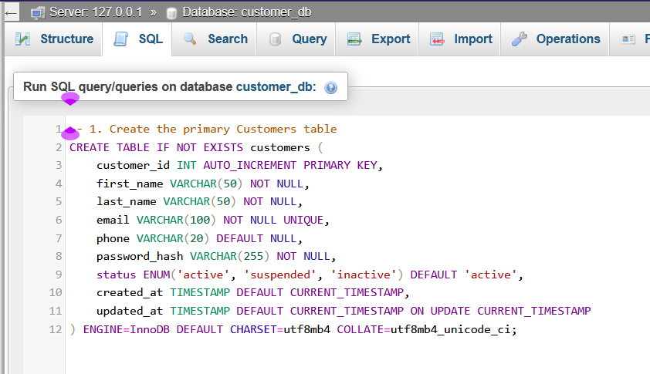
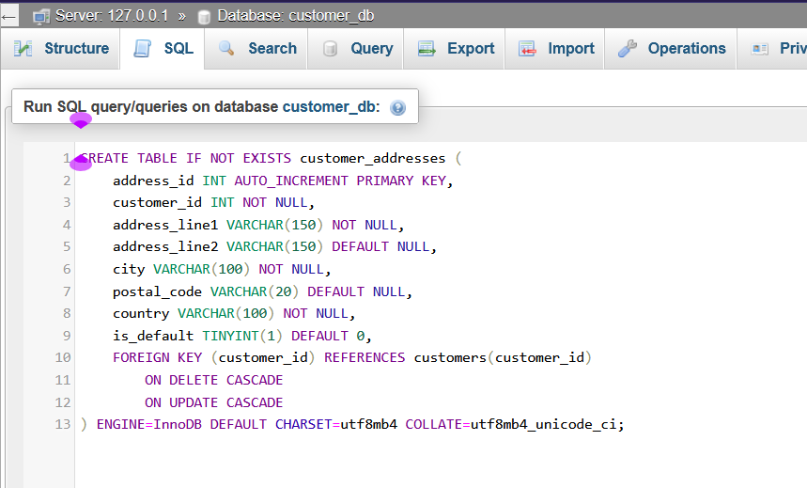

CRUD OPERATIONS

Figure 5.2.0: Create
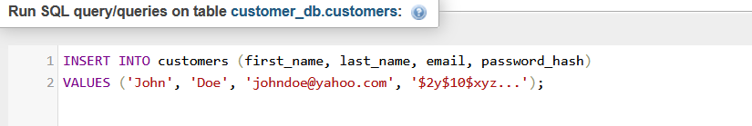

Figure 5.2.1: Read
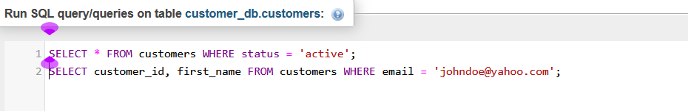

Figure 5.2.2: Update
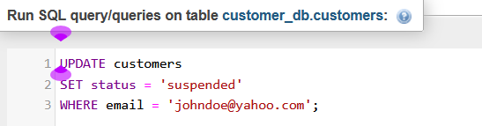

Figure 5.2.3: Delete
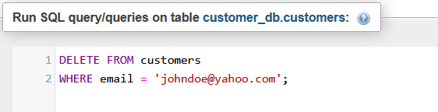
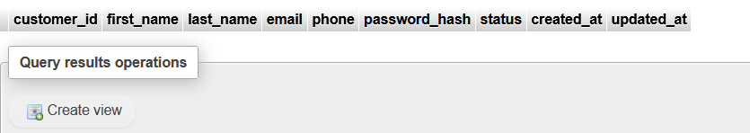

REPOSITORY UPDATE

Figure 5.3: GITHUB Updates page
